**Teacher Allocation System**

**User Manual**

Table of Contents

*The login Screen* 4

User Tab 5

Adding a User 5

Search for a User 6

Units Tab 6

Adding a Unit 7

Editing a Unit 8

Deleting a Unit 8

Searching for a Unit 9

*Preferences Tab* 10

To select a Preference 10

Edting a Preference 11

Deleting a Preference 11

Allocation Tab 12

To View Allocated Preferences 12

To Finialize Allocated Preferences 13

Reports Tab 13

To generate a report 14

To send a Report 15

**Welcome to the Teacher Allocation System**

The web address for the TAS:

http://www.deakin.edu.au/~nlha/tas

After typing in the web address, to proceed further click on the 'Proceed' button after reading the terms and conditions to the website. The website will proceed to the login page, the user will use their login credentials the TAS.

There are four different types of user's whom have different access level's. The tabs which are displayed for each user as follows:

**Teacher User:** Login, Preferences, Units and Allocations.

**System Administrator:** Login, Preferences, Units, Users, Reports and Allocations.

**Head of Institution:** Login, Preferences, Units, Allocation, Users and Reports.

**Teaching Administrator:** Login, Preferences, Units, Allocation and Users.

The '**Preferences' tab** contains information regarding what units there are to choose from. It is here where the teacher decides from 4 options:

A) Preferred B) Not Preferred C) Interested D) Unable

The **'Allocations' tab** contains the information regarding individual users allocated preferences. It is here a teacher can view their preferences, and the Head of Institute can finalize individual allocations.

The '**Reports' tab** contains reports on users allocated preferences. It is here that Administrators are able to generate reports and send them to the allocated user.

The **'Units' tab** contains all the units within the TAS. It is here users and Administrators can search for units. Also Administrators are able to change information regarding units. There is also the ability to delete units from this tab.

The '**Users' tab** contains the persons whom have credentials within the TAS. Here Administrators can search for users and also can add, edit and delete them.

**The login Screen**

Under the tab of 'Home', the TAS user login screen can be accessed. The user will login using the allocated user name and their own chosen password. There is the option of 'Remember me', this saves the user's credentials to allow faster access to the TAS.

Below is an example of how to log into the TAS.

Step 1) Enter user name

Step 2) Enter password

Step 3) Click 'Login'

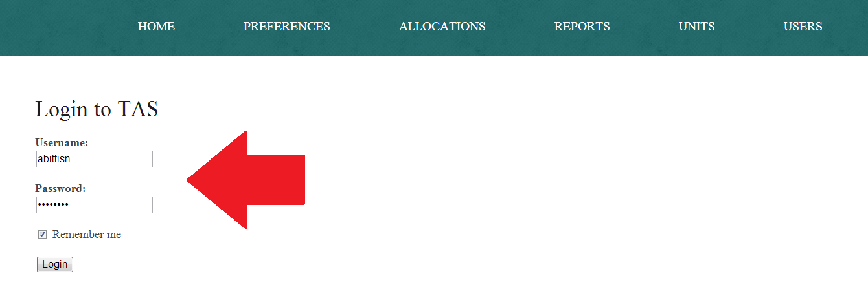

User Tab

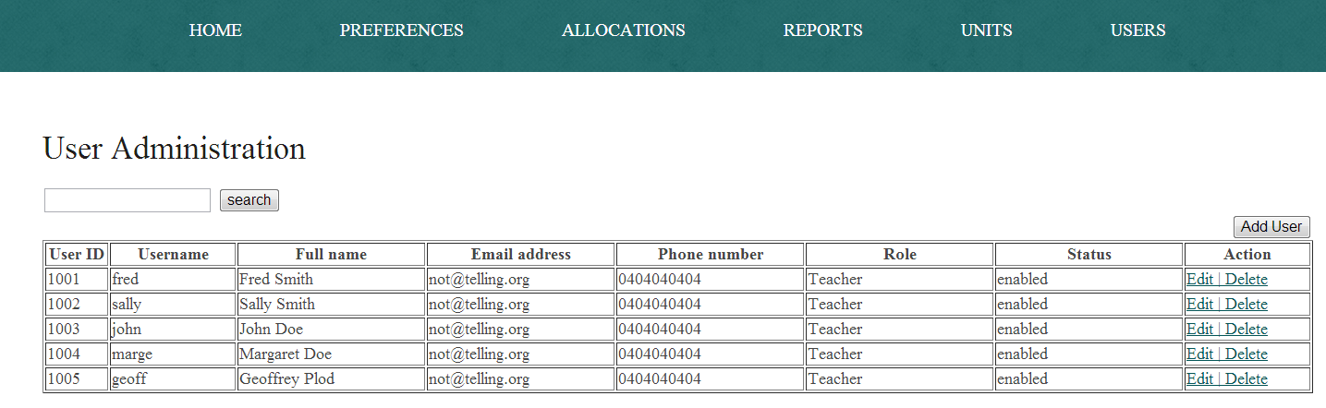The user tab which is only available to user's whom have approved access to this tab of the TAS. The user tab informs the administrator of all the users which have credentials within the TAS.

Adding a User

Only the System Administrator can add new users. To add a user, input User ID, Username, Password, Full Name, Email Address and Phone number. The administrator will pick a role for the user and if the user is active or suspended.

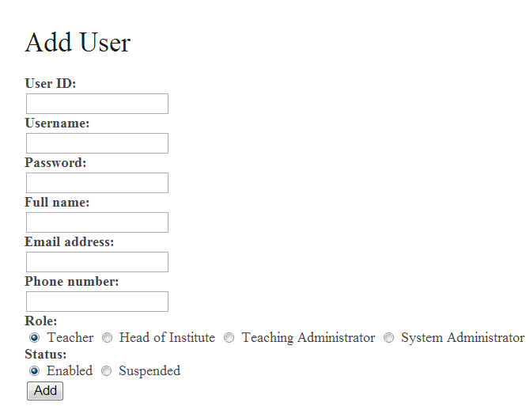

**Previous**

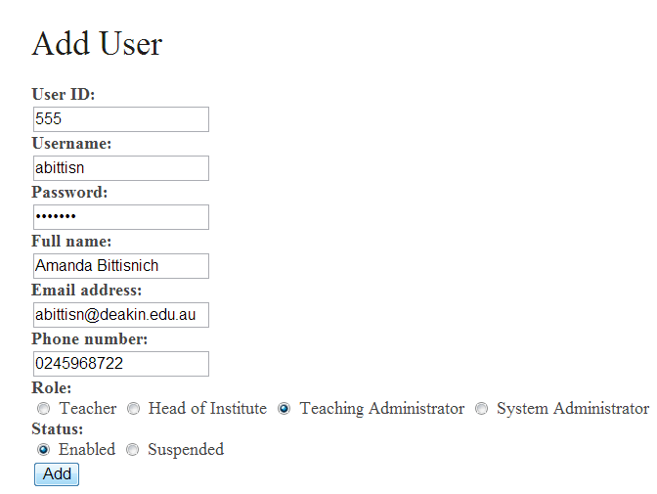

**Updated**

After the changed have been made, the 'User Added successfully' screen will be displayed.

Search for a User

To search for a user within the TAS, and type in the desired user

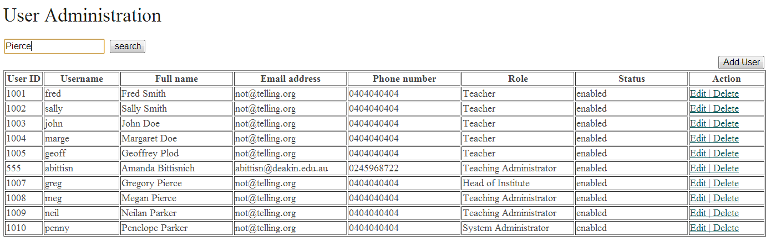

Units Tab

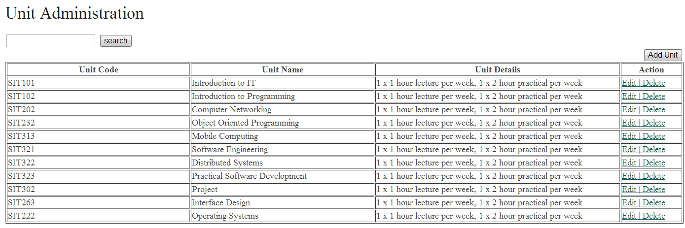The 'units' tab contains the units for the TAS. For each unit there is a Unit code along with the Unit Name. Each unit has Unit details which display how many hours and lecturers there are per a week, along with the length of the practical classes and how many there are per a week.

Adding a Unit

To add a unit, the user will click on the 'add unit' button, which will take you to this screen. To add a new unit, type in the Unit Code, Unit Name and the Unit details. After this has been done click on the 'Add' button.

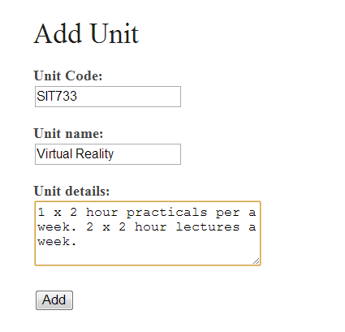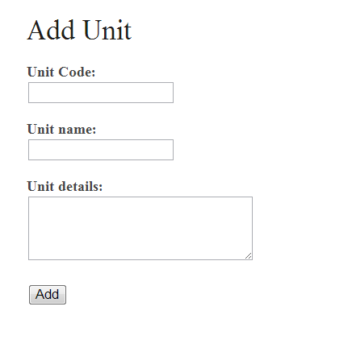

**Previous Updated**

After the changed have been made, the 'Unit Added Successfully' screen will be displayed.

Editing a Unit

To edit a unit, the user shall choose the unit which is required to be altered. Under the 'action' column is the ability to edit the unit. The system administrator will click on the 'Edit' link which will produce this screen. To edit the unit, enter the required changes and click 'Update'.

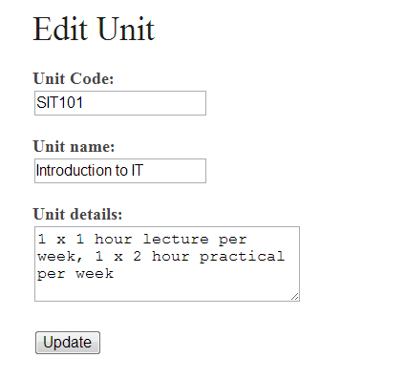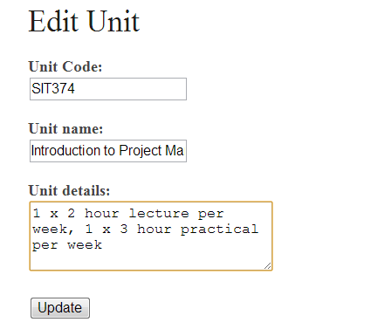

**Previous Updated**

After the changed have been made, the 'Update Successful' screen will be displayed.

Deleting a Unit

To delete a unit, the user will select a unit to delete and click on the 'delete button'.

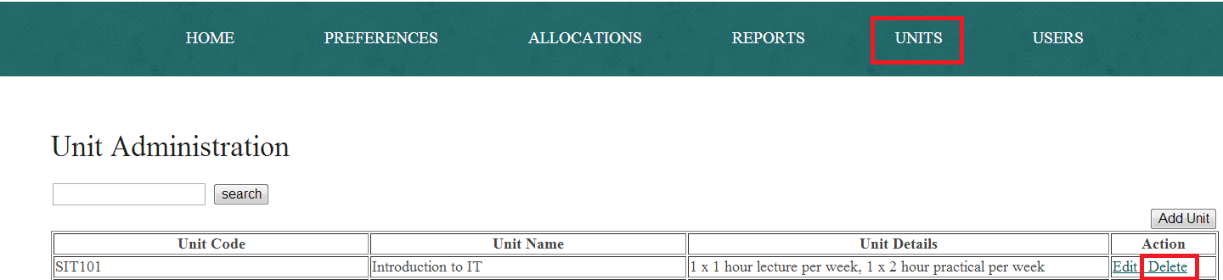

After clicking on the delete button, the next screen will be displayed to confirm the decision made.

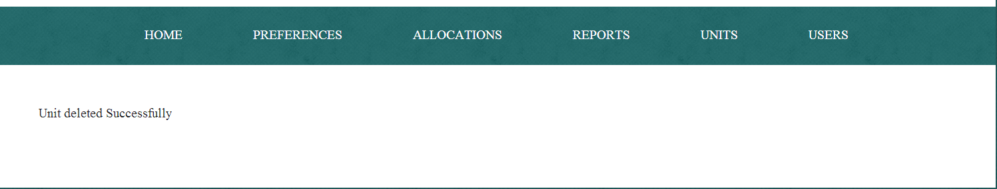

Searching for a Unit

To search for a unit, click on the 'Unit' tab and type in the desired unit search.

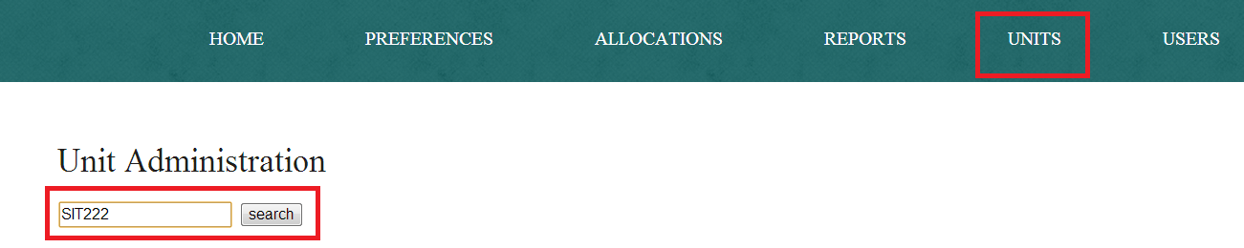

After clicking search, the unit requested will be displayed.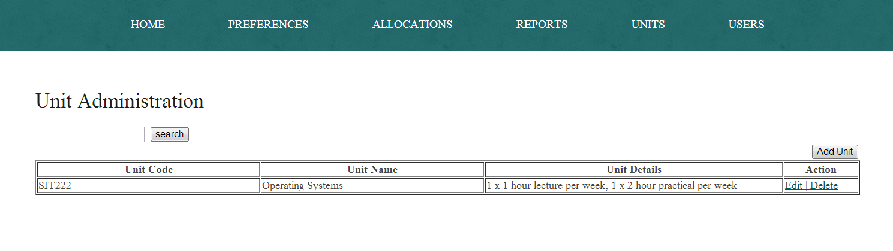

**Preferences Tab**

After the user has logged into the TAS, the next step is for the user to select their preferences. This screen will display the units of which the user is able to select from. From here a user is able to input their preferences.

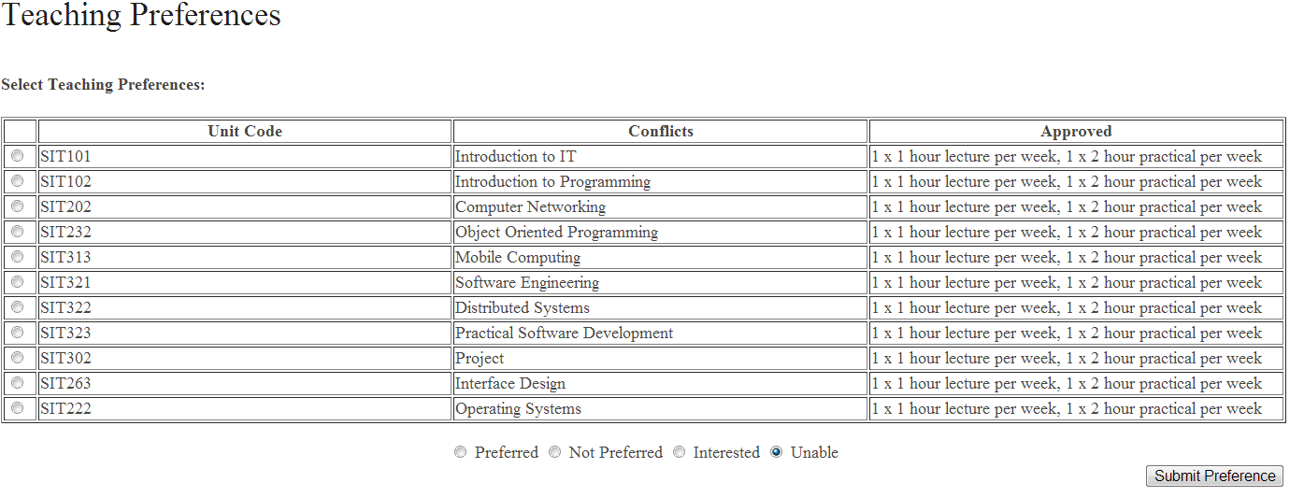

To select a Preference

To select a preference, click on the circle next to the unit code to select that preference. After choosing the preference, select the desired decision. There are 4 decisions that can be chosen from.

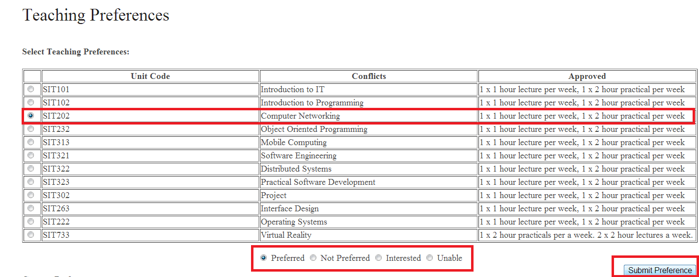**1) Prefered 2) Not Prefered 3) Interested 4)Unable**

After the decisions have been made, click on the submit preference button to submit the decision.

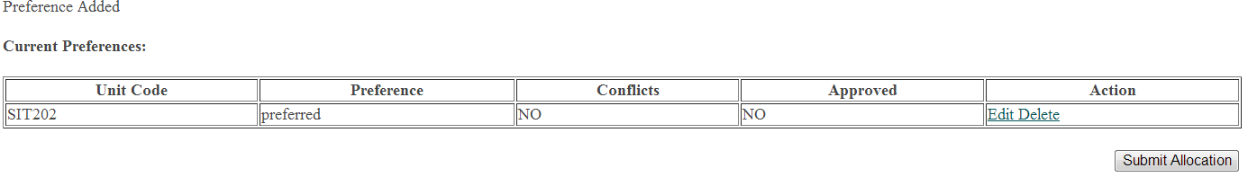

Edting a Preference

To edit a preference which has already been chosen, it is still possible to edit it. The user needs to select a preference to make changes to. The user will click on the 'Edit button

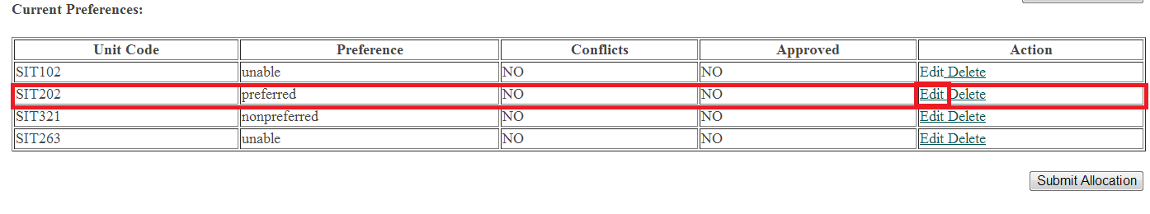

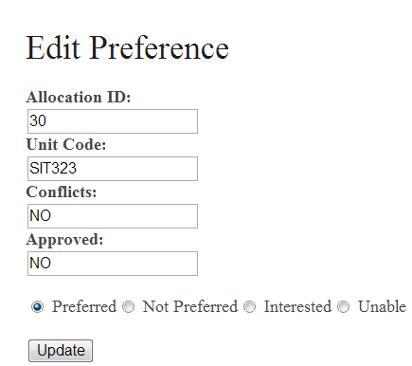After clicking on the 'edit' button, the edit preference screen will be shown. Add the new information to the 'edit preference' screen.

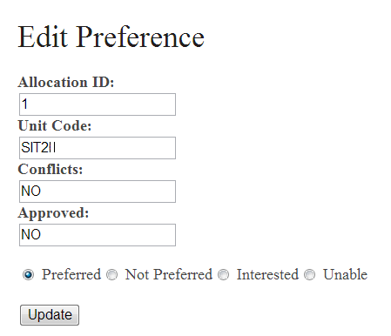

**Previous Updated**

Deleting a Preference

To delete a preference which has already been chosen, it is possible to delete it. The user needs to select a preference to make changes to. To delete, the user will select a unit to delete and click on the 'delete' button.

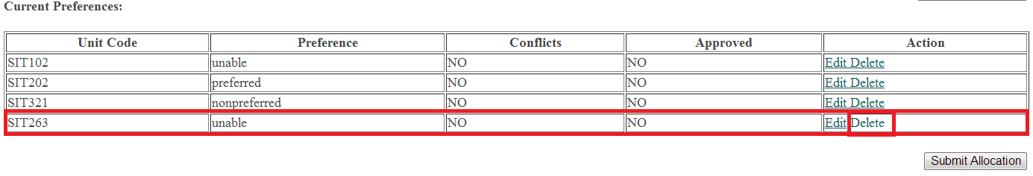

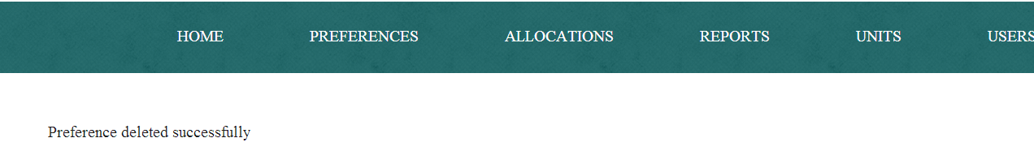After deleting a preference, the screen below will be displayed to confirm approval.

Allocation Tab

The allocation tab contains the users whom have chosen their preferences into the TAS. This screen is where all users can see what units have been allocated.

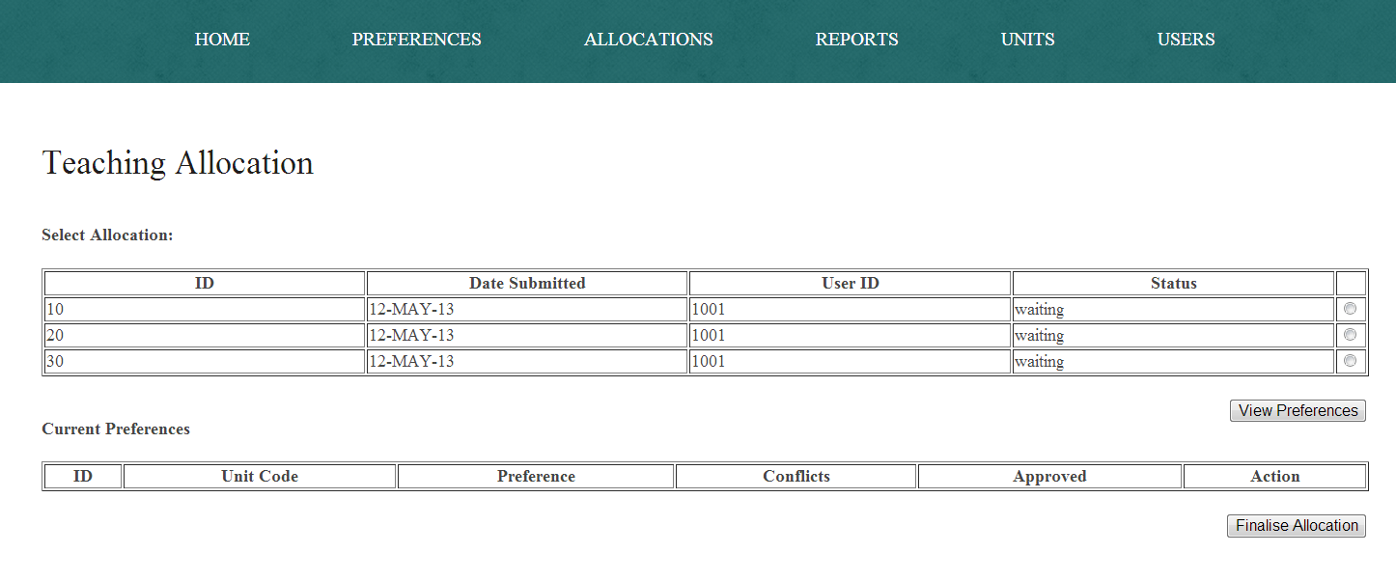

To View Allocated Preferences

To view preferences, select a user's ID to view what preferences have been allocated to them. Select a user to view their allocation by clicking on the radio button next to 'Status'. After selecting the user, click on the 'View Preferences' button to see what has been allocated to the user.

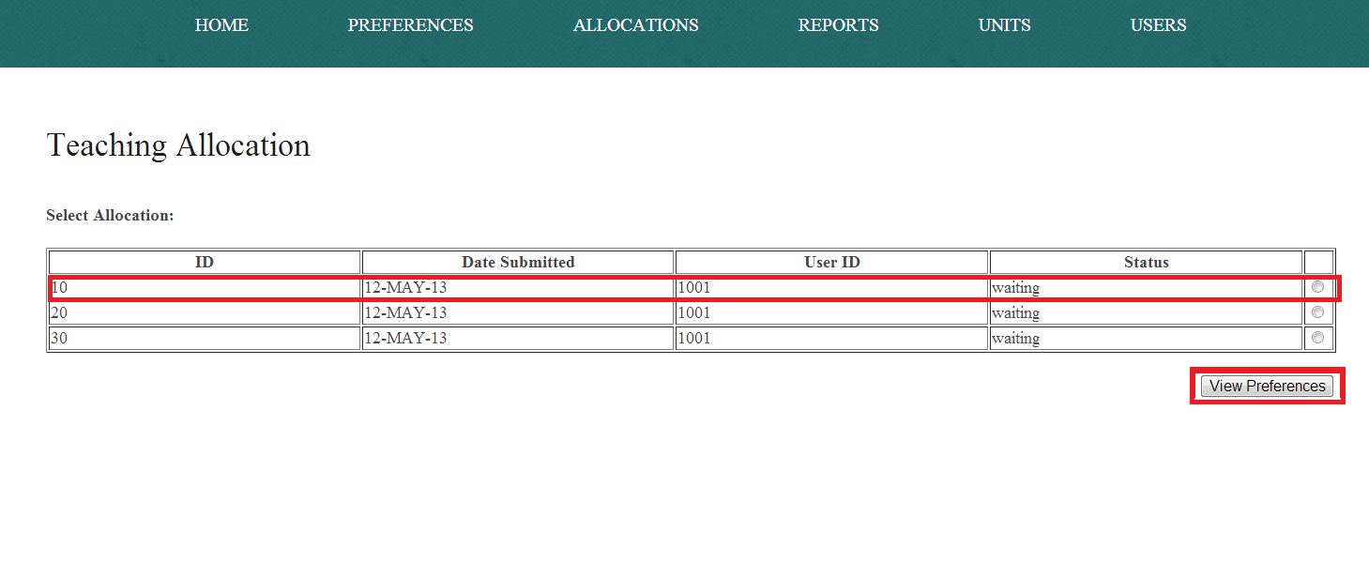After clicking 'View Preferences' the TAS will show what units have been allocated to a user.

To Finialize Allocated Preferences

To finalize allocations for a user, the preferences will be displayed after clicking and viewing preferences. *For more infomation on 'Viewing Preferences' see page 7.*

Finalising preferences:

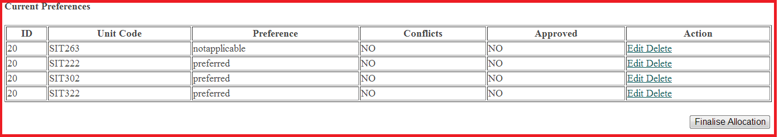 **Click on the Finalise Allocation button.**

Reports Tab

The reports tab contains the ability to create a report for an individual user. There is also the ability to see the allocation statistics. There are statistics that describe the number of allocations in the system, the total number of allocations in this submission cycle and the total number of allocations waiting for finalising.

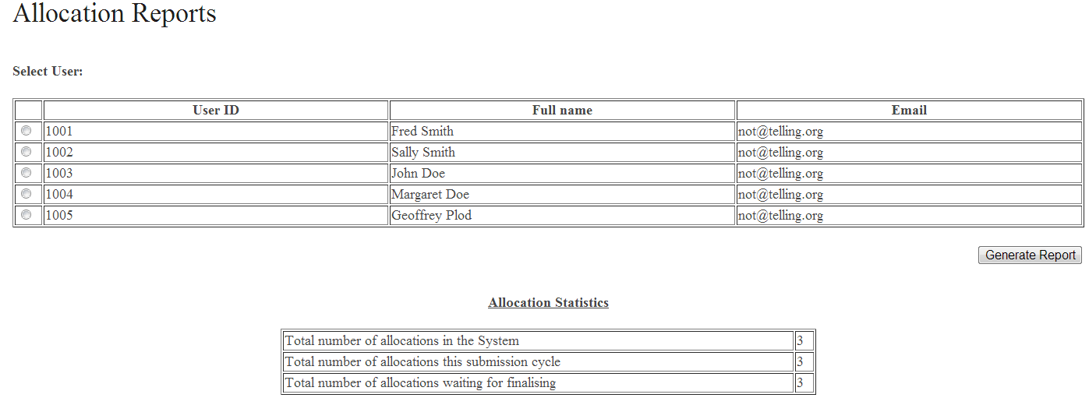

To generate a report

To generate a report, click on the radio button next to the UserID to select the desired user. Then click generate report.

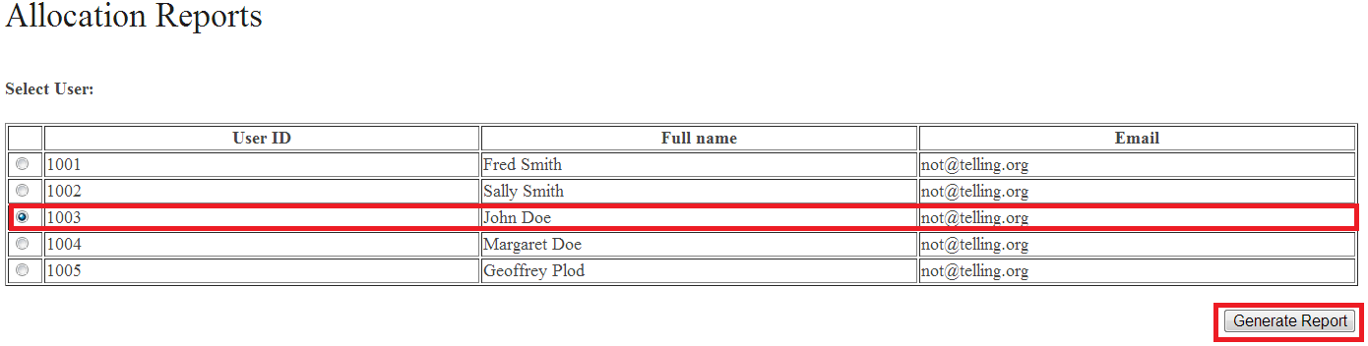

After the button has been clicked the report will be generated. The report contains the Allocated preferences which have been given to the chosen user.

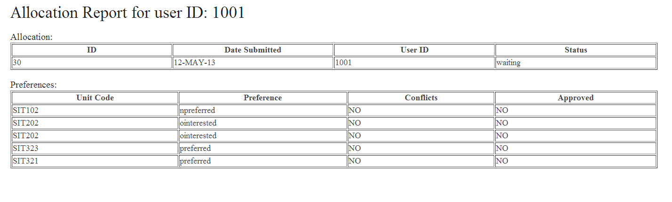

To send a Report

To send a report click on the 'send report' button in the generated user report. *To generate a report refer to page 13, Under 'To generate a report'.*

